Algoritmos T.P. N° 6 – Algoritmos de ordenamiento Avanzado - Juan Cruz Ambrosini

Ejercicio 1

from mylinkedlist import *
import random

def quickSortR(list : LinkedList, resultList : LinkedList = LinkedList()):

size = lengthList(list)

if size > 1 :

pivotIndex = random.randint( 0 , size - 1)
current : Node = list.head
pivot = searchNodeIndex(list, pivotIndex)
pivotValue = pivot.value
low = LinkedList()
high = LinkedList()

while(current != None):

if (current.value < pivotValue) :
add(low, current.value)
elif current.value == pivotValue and current != pivot :
add(low, current.value)
else:
add(high, current.value)
current = current.nextNode

quickSortR(low, resultList)
quickSortR(high, resultList)

else:
if list.head != None:

add(resultList, list.head.value)

return resultList

def quickSort(list : LinkedList) -> LinkedList :
result = quickSortR(list)
invertList(result)

return result

"""---------------------------------------------------------------------------------------------"""

def mergeSort(list : LinkedList) :

if list.head.nextNode == None or list.head == None:
return list
else:

l1, l2 = splitList(list)
mergedList1 = mergeSort(l1)
mergedList2 = mergeSort(l2)

return merge(mergedList1, mergedList2)

"""---- ---- ---- ---- ---- ---- ---- ---- ---- ---- ---- ---- ---- ---- ---- ----"""

def merge(list1 : LinkedList, list2 : LinkedList) :

mergedList = LinkedList()
currentL1 : Node = list1.head
currentL2 : Node = list2.head

while(currentL1 != None and currentL2 != None):
if (currentL1.value <= currentL2.value):
add(mergedList, currentL1.value)
currentL1 = currentL1.nextNode
else:
add(mergedList, currentL2.value)
currentL2 = currentL2.nextNode

while currentL1 != None :
add(mergedList, currentL1.value)
currentL1 = currentL1.nextNode

while currentL2 != None :
add(mergedList, currentL2.value)
currentL2 = currentL2.nextNode

invertList(mergedList)

return mergedList

"""---------------------------------------------------------------------------------------------"""

def heapify(list : LinkedList):

n = lengthList(list)

for i in reversed(range(n//2)) :
shiftDown(list, i)

"""---- ---- ---- ---- ---- ---- ---- ---- ---- ---- ---- ---- ---- ---- ---- ----"""

def shiftDown(list : LinkedList, index : int):

n = lengthList(list)
maxIndex = index
leftIndex = 2 * index + 1
rightIndex = 2 * index + 2

if leftIndex < n or rightIndex < n:

if leftIndex < n:
if searchNodeIndex(list, leftIndex).value > searchNodeIndex(list, maxIndex).value :
maxIndex = leftIndex

if rightIndex < n:
if searchNodeIndex(list, rightIndex).value > searchNodeIndex(list, maxIndex).value :
maxIndex = rightIndex

if maxIndex != index:

swap(list, maxIndex, index)
shiftDown(list, maxIndex)

"""---- ---- ---- ---- ---- ---- ---- ---- ---- ---- ---- ---- ---- ---- ---- ----"""

def shiftDownTo(list : LinkedList, index : int, till : int):

n = lengthList(list)
maxIndex = index
leftIndex = 2 * index + 1
rightIndex = 2 * index + 2

if (leftIndex < n or rightIndex < n) :

if leftIndex < till:
if searchNodeIndex(list, leftIndex).value > searchNodeIndex(list, maxIndex).value :
maxIndex = leftIndex

if rightIndex < till:
if searchNodeIndex(list, rightIndex).value > searchNodeIndex(list, maxIndex).value :
maxIndex = rightIndex

if maxIndex != index:

swap(list, maxIndex, index)
shiftDownTo(list, maxIndex, till)

"""---- ---- ---- ---- ---- ---- ---- ---- ---- ---- ---- ---- ---- ---- ---- ----"""

def heapSort(list : LinkedList) :

heapify(list)
n = lengthList(list)

for i in reversed(range(0, n )):
swap(list, 0, i)
shiftDownTo(list, 0, i)

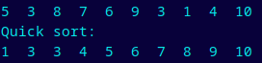

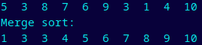

Ejercicio 2

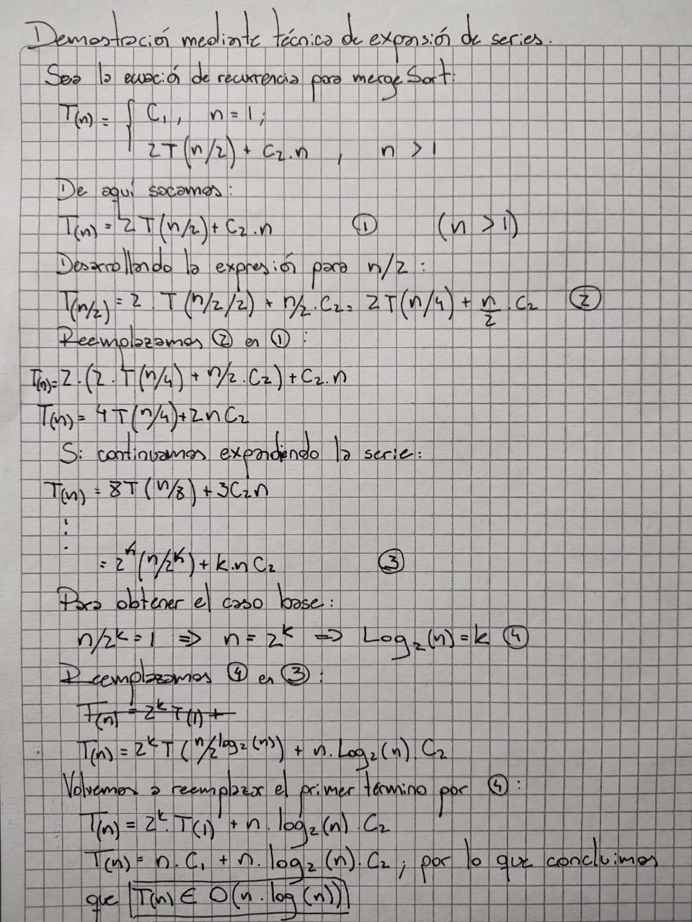
Ejercicio 3

def heapify(list : LinkedList):

n = lengthList(list)

for i in reversed(range(n//2)) :
shiftDown(list, i)

"""---- ---- ---- ---- ---- ---- ---- ---- ---- ---- ---- ---- ---- ---- ---- ----"""

def shiftDown(list : LinkedList, index : int):

n = lengthList(list)
maxIndex = index
leftIndex = 2 * index + 1
rightIndex = 2 * index + 2

if leftIndex < n or rightIndex < n:

if leftIndex < n:
if searchNodeIndex(list, leftIndex).value > searchNodeIndex(list, maxIndex).value :
maxIndex = leftIndex

if rightIndex < n:
if searchNodeIndex(list, rightIndex).value > searchNodeIndex(list, maxIndex).value :
maxIndex = rightIndex

if maxIndex != index:

swap(list, maxIndex, index)
shiftDown(list, maxIndex)

"""---- ---- ---- ---- ---- ---- ---- ---- ---- ---- ---- ---- ---- ---- ---- ----"""

def shiftDownTo(list : LinkedList, index : int, till : int):

n = lengthList(list)
maxIndex = index
leftIndex = 2 * index + 1
rightIndex = 2 * index + 2

if (leftIndex < n or rightIndex < n) :

if leftIndex < till:
if searchNodeIndex(list, leftIndex).value > searchNodeIndex(list, maxIndex).value :
maxIndex = leftIndex

if rightIndex < till:
if searchNodeIndex(list, rightIndex).value > searchNodeIndex(list, maxIndex).value :
maxIndex = rightIndex

if maxIndex != index:

swap(list, maxIndex, index)
shiftDownTo(list, maxIndex, till)

"""---- ---- ---- ---- ---- ---- ---- ---- ---- ---- ---- ---- ---- ---- ---- ----"""

def heapSort(list : LinkedList) :

heapify(list)
n = lengthList(list)

for i in reversed(range(0, n )):
swap(list, 0, i)
shiftDownTo(list, 0, i)
